Project Synopsis On

# Stock Price Prediction Using Deep Learning

By

## Tejas Samrut (Roll no - 01) Vinay Badgujar (Roll no - 02) Sibin Varghese (Roll no - 67)

Under Guidance of

## Prof. Pragati Patil



Department of Information Technology Vidyavardhini’s College of Engineering & Technology

University of Mumbai

2022-2023

Vidyavardhini’s College of Engineering & Technology Department of Information Technology

Certificate

*This is to certify that the following students*

### Tejas Samrut Vinay Badgujar Sibin Varghese

*have submitted project synopsis entitled*

## Stock Price Prediction Using Deep Learning

*as a part of their project-work in partial fulfilment of Semester VII of* ***Bachelor of Engineering*** *in* ***Information Technology*** *during academic year 2022-2023.*

|  |  |  |
| --- | --- | --- |
| Internal Guide | : ( | ) |
| External Guide | : ( | ) |
| Internal Examiner | : ( | ) |
| External Examiner | : ( | ) |

#### Dr. Thaksen Parvat Dr. Harish Vankudre

HOD - IT, Principal,

VCET, Vasai VCET, Vasai

# Declaration

We declare that this written submission represents our ideas in our own words and where others’ ideas or words have been included, we have adequately cited and refer- enced the original sources. We also declare that we have adhered to all principles of academic honesty and integrity and have not misrepresented or fabricated or falsified any idea/data/fact/source in our submission. We understand that any violation of the above will be cause for disciplinary action by the Institute and can also evoke penal action from the sources which have thus not been properly cited or from whom proper permission has not been taken when needed.

#### Tejas Samrut ( )

**Vinay Badgujar ( )**

#### Sibin Varghese ( )

Date :

# Abstract

In this project we attempt to implement deep learning approach to predict stock prices. Deep learning is effectively implemented in forecasting stock prices. For accurate investment decisions it is important to predict stock price with better accuracy, which is the main objective of the project. We propose a system that will predict price of stocks and to achieve better accuracy and prediction of stocks the system involves integration of deep learning, various mathematical functions and other external factors. One of the most rapidly expanding research areas in today’s world is Sentiment Analysis. Social Media websites like Twitter have become a source of wide variety of information. This is because in today’s world the people use social media sites, blogs to share their views or opinions and ideas about specific service, organization or specific product. In this system, we are going to deal with some popular social media sites like Twitter and with help of that we are going to create a system which will get insights about the sentiments related to different stocks from the fetched Tweets. Real-Time Tweets are fetched from Twitter using the API called TweepyAPI, and then to remove unwanted words and characters from the tweet cleaning is performed. The library called TextBlob which is used to assign separate polarities to the tweets and after that Total Polarity for the concerned stock is determined. [3]

# Contents

1. Introduction 1
   1. Overview 1
   2. Motivation 1
   3. Problem Statement 2
   4. Organization and Contributions of the Report 2
2. Review of Literature 3
   1. Overview 3
   2. Papers Referred 3
      1. Stock Market Prediction Using Machine Learning 3
      2. Forecasting the Stock Market Index Using Artificial Intelligence Techniques 4
      3. Indian stock market prediction using artificial neural networks

on tick data 5

1. Report on The Present Investigation 6
   1. General Methodology for Prediction 6
   2. Hardware/Software required 7
   3. Design 8
      1. Structure Chart 8
      2. UML Diagrams 9
      3. Flowchart 9
2. Results and Discussions 11
3. Conclusion and Future Work 13
   1. Conclusion 13
   2. Future work 13

Contents

Appendix A 14

Appendix B 14

**List of Figures**

* 1. LSTM ARCHITECTURE 7
  2. Structure Chart 8
  3. Flow Chart 10

# List of Abbreviations

LSTM Long Short-Term Memory ATS Automated Trading System GRU Gated Recurrent Unit

ML Machine Learning SVM Support Vector Machine

EMH Efficient Market hypothesis AI Artificial Intelligence

NN Neural Networks

ARMA Autoregressive Moving Average DRL Deep Reinforcement Learning LMS Least Mean Square

UML Unified modelling Language MSE Mean Squared Error

RMSE Root Mean Squared Error

# Chapter 1 Introduction

## Overview

The money market may be a dynamic and huge system wherever folks can purchase and sell currencies, stocks, etc. over sure platforms that ar supported by brokers. Stock market permits several investors to possess specific amount of shares from sure public companies through commerce markets. This market has given several investors a boon of gaining cash and having a large life through finance little amounts of cash and has less risk compared to the chance of starting of an enormous new business or the need of obtaining high vary remuneration career. Stock markets is obtaining laid low with n number of things inflicting the high volatility within the market. Sentiment Analysis of Real Time Tweets of the many money firms is a shot to urge an summary of the trends in future costs of that exact company’s stock. Real Time Tweets for NASDAQ (American stock market) stocks and NSE (Indian stock market) stocks were mainly grasped using/form the Tweepy API. These tweets ar being processed so as to remove sure unwanted characters and so passed into the library that brings clarity to several individual tweets.

## Motivation

Majorly, businesses run on rating proposed by customers on online forum and ratings Shifts in sentiment analysis, social media have been a import asset stock markets. Identifying customer grievances thereby resolving their problems will lead to customer satisfaction as well as great bond of an organization with the customers. Hence it is necessary for an system to separate customer reviews connected with any sort of

Chapter 1. *Introduction*

problem. In current scenario where we are justifiably suffering from overloading of data (but this does not mean bigger insights), companies might have large amount of customer feedback collected from different sources; but for humans, it’s still impossible to review it manually without error or bugs. Many times companies which carry the best intentions find themselves in an crossover of vacuum. You need to know insights to make work out of your decision making and you know that you’re lacking them, but have no idea of how to get best out of them. With the help of Sentiment Analysis we get to know about important issues are, from the perspective of customers. Because sentiment analysis can be automated and decisions can be made on the basis of a large amount of data than plain intuition.

## Problem Statement

The exchange seems within the news each day. You hear concerning it when it Date 2022-11-06 Words 641 Characters 4246 Page 1 of 2 reaches a replacement high or a replacement low. the speed of investment and business opportunities in the exchange will increase if Associate in Nursing economical algorithmic rule can be devised to predict the short term value of a personal stock.Time Series statement modelling plays a significant role in knowledge analysis. statistic analysis. And because it may be a specialised branch of statistics used extensively in fields like economics, Operation analysis etc.[1] Time Series is being wide utilized in analytics knowledge science. Stock costs ar volatile in nature and value depends on varied factors. the most aim of this specific project is to predict stock costs exploitation Long short term memory(LSTM).

## Organization and Contributions of the Report

The Main contributions of this report ar as follows- –To develop a best model that can predict stock costs with best accuracy. The project report’s Introduction is that the first of the four chapters that form up the general document. the opposite chapters of the report ar organized as follows: Chapter a pair of discusses the project’s literature review; Chapter three provides the report on this investigation; and Chapter four contains the Results Discussions. The Conclusions and also the work we tend to hope to perform moving forward with this project ar enclosed within the final Chapter five

# Chapter 2

**Review of Literature**

## Overview

Opinion folks—of individuals has continuously been a awfully necessary matter of information for many people during the time of decision-making. Infobahn has been have presently (among varied things) created it potential or collaborating in Associate in Nursing passing major role to hunt out out relating to the opinions and experiences administrated of these at intervals the ocean of individuals that unit neither treated as our personal opinions or well-known skilled critics — as folks we’ve got got ne’er detected of. And mainly, a lot of and a lot of people unit creating their responses on the market to the world through Infobahn. The interest that folks show in on-line opinions/matters about ample of product and services, and to boot the influence such opinions created, is something that’s forcing the force for to induce a lot of data relating to this specific field. And there unit really slew of challenges concerned throughout this specific process that must be stepped all over thus on induce correct outcomes from them. In this specific survey, we’ve been analyzing some ways that generally carry out in this technique and measures that unit to be administrated to beat the challenges that has been facing.

## Papers Referred

### Stock Market Prediction Using Machine Learning

n this monetary world commerce has become one in each of the foremost impor- tant/critical activities. Stock market prediction is associate act of making an attempt to figure out the worth of a stock listed on a economical exchange. This paper explains

Chapter 2. *Review of Literature*

the prediction of a stock exploitation bound Machine Learning Algorithms. The tech- nical and elementary analysis is employed by 3 Chapter 2. Review of Literature the most of the stock traders whereas creating the stock predictions. The programming language that we’ve got got accustomed predict the exchange exploitation machine learning is Python.[5] throughout this project we’ve Associate in Nursing inclination to propose a Machine Learning (ML) approach which may be trained from the on the market stocks knowledge and gain ample quantity of intelligence then uses the infor- mation gathered for associate smart prediction. throughout this context this study uses a machine learning technique referred to as Support Vector Machine (SVM) to predict stock prices of the big and small organizations and at intervals the 3 all all completely different markets

### Forecasting the Stock Market Index Using Artificial In- telligence Techniques

The weak type of EMH states that it’s extremely strong to predict the price of asso- ciate quality Date 2022-11-06 Words 813 Characters 5649 Page 1 of 2 based on the information retrieved at intervals the earlier costs of associate quality. this implies that the market behaves as a cake walk and as a result makes predicting nearly not possible. Financial prediction is additionally an enormous task thanks to the quality of the economical system.[6] The main objective of this project was to use comput- ing (AI) techniques to model and predict the long haul price of a stock happiness to specific organization. Two computing techniques, namely, neural networks (NN), support vector machines unit enforced in predicting the long haul price of a exchange supported its historical price knowledge. computing techniques have the power to take into thought economical.[2] The linear Modelling technique Autoregressive Mov- ing Average(ARMA) and random walk(RW) that unit accustomed benchmark the AI techniques. The experiment that was performed on knowledge obtained from the ex- change. the data used was past valuation data of terms of index. The results showed that the 3 techniques have the capability to forecast the price of the Index with asso- ciate higher accuracy. All 3 AI techniques out performed the model.[5] but, all varied techniques were performed by model. These techniques show associate capability to forecast the long haul price however, thanks to the prices of transactional commerce at intervals the market, it’s out of the question to figure out that the 3 techniques will contradict the weakest type of exchange efficiency. The results show that the ranking of performances support vector machines, multilayer perceptron neural networks is totally hooked in to the accuracy used.

Chapter 2. *Review of Literature*

### Indian stock market prediction using artificial neural networks on tick data

A stock market is a giant platform for purchasing of a company’s stocks and derivatives at an mortal price. Supply and demand of shares chain boost the stock market. In any country stock market is considered as one of the most emerging and highlighted sectors.[4] Nowadays, many people are directly or indirectly related to this particular sector. Therefore, it becomes essential to know about current market trends. These techniques show an capability to forecast the future price however, because of the costs of transactional trading in the market, it is not possible to figure out that the three techniques can disprove the weakest form of stock market efficiency. The results show that the ranking of performances support vector machines, multilayer perceptron neural networks is completely dependent on the accuracy used.

# Chapter 3

**Report on The Present Investigation**

## General Methodology for Prediction

The prediction strategies are often roughly divided into 2 classes, applied mathematics strategies and AI strategies. the strategy referred to as applied mathematics embrace ARCH model, provision regression model, etc. multilayer perceptron enclosed by AI methods, CNN(convolutional neural network), network that area unit referred to as naive Bayes, SVM(support vector machine), back propagation network, continual neu- ral network, single-layer LSTM. They used Long remembering network (LSTM).Long short-term memory network (LSTM) is restricted kind of RNN (Recurrent Neural Network). LSTM may be a special network structure with 3 “gate” structures. In Long short-term memory unit 3 gates area unit placed that area unit referred to as output gate, forgetting gate and input gate. info—the knowledge—the data is opt for by rules once information comes in the LSTM’s network. data that conforms with the rule solely that data is going to be there, and remaining data that doesn’t change with the rule goes to be forgotten victimisation the forgetting gate. the info we tend to experimented in this project area unit historical knowledge that area unit downloaded from yahoo finance. In the project 3 sorts of datasets were used. it’s required to seek out AN improvement algorithm that needs less resources and has quicker convergence speed. • Used Long remembering (LSTM) with embedded layer and also the LSTM neural network with automatic encoder. • LSTM is employed rather than RNN to avoid exploding and vanishing gradients.

Chapter 3. *Report on The Present Investigation*

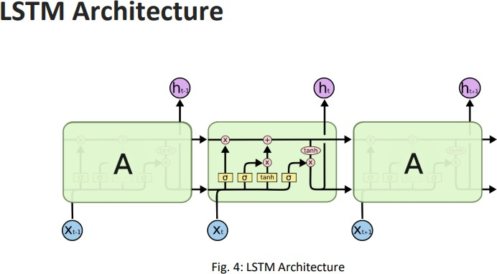

Figure 3.1: LSTM ARCHITECTURE

begincentering

## Hardware/Software required

Requirements are RAM of 4 GB, Storage of 500 GB, CPU with 2 GHz or faster, Ar- chitecture of 32-bit or 64-bit. Software Requirements: Python 3.5 in Google Colab is used for data pre-processing, model training and prediction. Operating System: win- dows 7 and above or Linux based OS or MAC OS Functional requirements Functional requirements describe what the software should do (the functions). Think about the core operations. Because the “functions” are established before development, func- tional requirements should be written in the future tense. In developing the software for Stock Price Prediction, some of the functional requirements could include: on input for model training. The software shall use LSTM ARCHITECTURE as main compo- nent of the software. It processes the given input data by producing the most possible outcomes of a CLOSING STOCK PRICE.

Chapter 3. *Report on The Present Investigation*

## Design

### Structure Chart

Structure chart is chart in structure theory and code engineering that shows the system breakdown to its lowest manageable level. In structured programming, to arrange program modules into tree they’re used. Box represent every module, and box contains the module’s name.

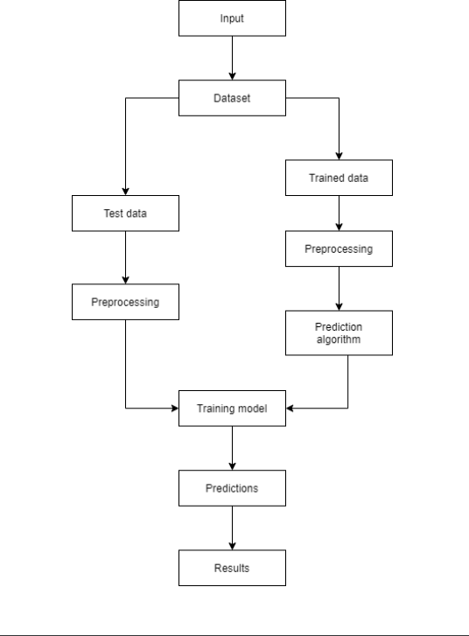

Figure 3.2: Structure Chart

Chapter 3. *Report on The Present Investigation*

### UML Diagrams

A diagram referred to as UML is partial graphical representations of model of system beneath implementation, style or already gift. UML diagram contains graphical parts (symbols) - Graphical parts area unit gift in UML diagram edges area unit connected with UML nodes, the perimeters also are referred to as as flows or methods that represents component of element of model. alternative documentation like use cases written as templated texts Date 2022-11-06 Words 795 Characters 5609 Page 1 of 2 this conjointly contain within the UML model of system. By the first graphical image in figure the sort of diagram or figure is outlined. for instance, category diagram in classes wherever primary symbols area unit in contents. Message exchanges between lifelines is shown by sequence diagrams. UML doesn’t preclude combining varied kings of figures or diagrams, for instance to combine behavioural and structural parts within a use case to indicate a state machine nested. consequently, the boundries between the different varieties of figures or diagrams don’t seem to be enforced strictly. At that actual time, working on specific kind diagrams UML Tools do forbid set of obtainable graphical elements. Behavior diagrams and structure diagrams area unit 2 varieties of UML diagrams which UML specification defines. Static structure of system and its varied elements on various implementation and abstraction levels and the way they’re connected with every other is shown by structure diagrams.[1] significant ideas of system area unit described by the weather in structure diagram, and it’s going to add implementation ideas, real world and abstract. within the system the object’s dynamic behavior is shown by behavior diagrams, which may be careful as sequence of changes to the system over time. 3.3.3 flow diagram A particular method or advancement is described victimisation the flow diagram. A diagrammatical representation of AN rule, a gradual approach to finding task is outlined by flowchart. steps as boxes of variouskinds is shown by the flow diagram, and y connecting the boxes with arrows shows their order.[6]

### Flowchart

A particular process or workflow is represented using the flowchart. A diagrammatic representation of an algorithm, a step-by-step approach to solving task is defined by flowchart. steps as boxes of variouskinds is shown by the flowchart, and y connecting the boxes with arrows shows their order.

Chapter 3. *Report on The Present Investigation*

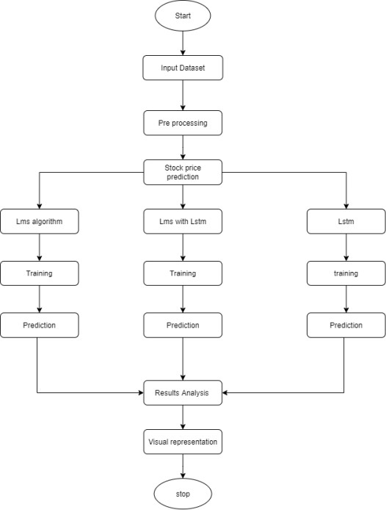

Figure 3.3: Flow Chart

# Chapter 4

**Results and Discussions**

Predicting the stock value correlation of the many assets for the fundamental measure is very important in stock value improvement. we tend to apply LSTM continual neural networks (RNN) to forecast the stock value constant of 2 individual stocks. RNN’s area unit extremely agggressive in understanding temporal issues/dependencies. the uti- lization of LSTM boost or enhances its long-term foreseeable properties. To deal each one-dimensionality and non-linearity within the model, we adopt the ARIMA model as we tend toll—also additionally further furthermore in addition likewise moreover similarly still yet. The ARIMA model filters great amount of linear tendencies therein specific knowledge and passes on the core worth to the LSTM model. The LSTM hybrid model is tested against alternative ancient foreseeable economical models like the complete historical recent model, constant-model, single indexmodel and the multi cluster model. In our deep study, the prophetical ability of the LSTM model turned out to be so much superior to any or all alternative economical models by a major quantity of scale. Our work implies that it’s value considering the LSTM model to predict the correlation coefficient for stock improvement.

Chapter 4. *Results and Discussions*

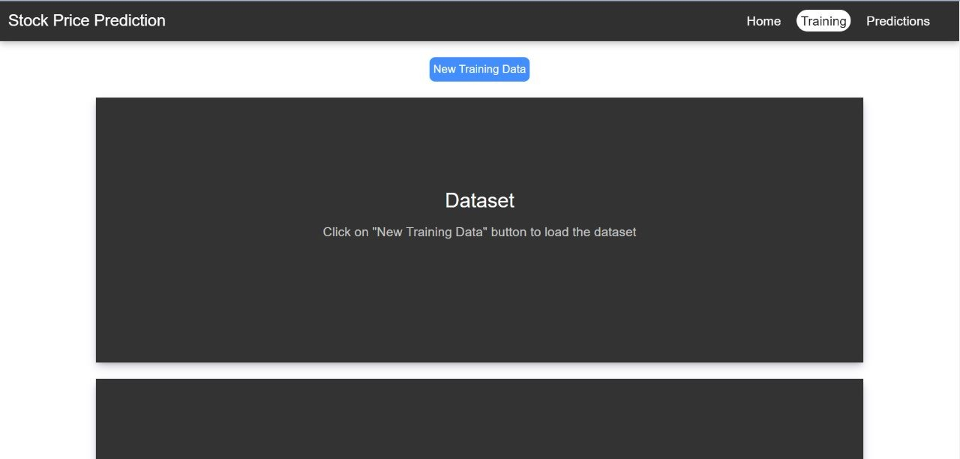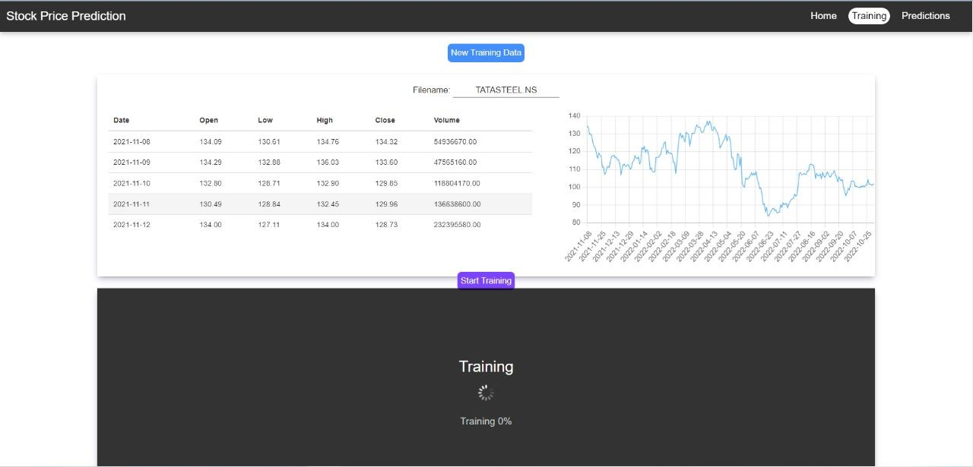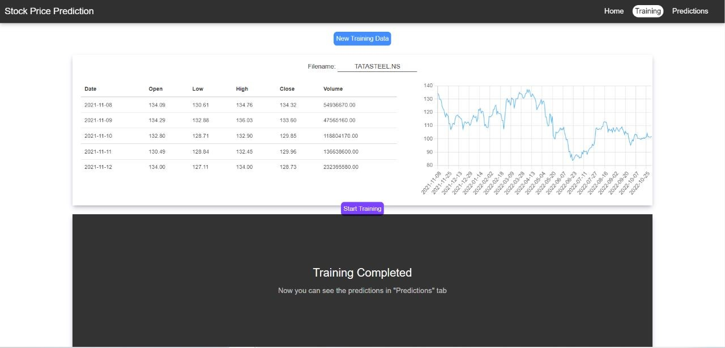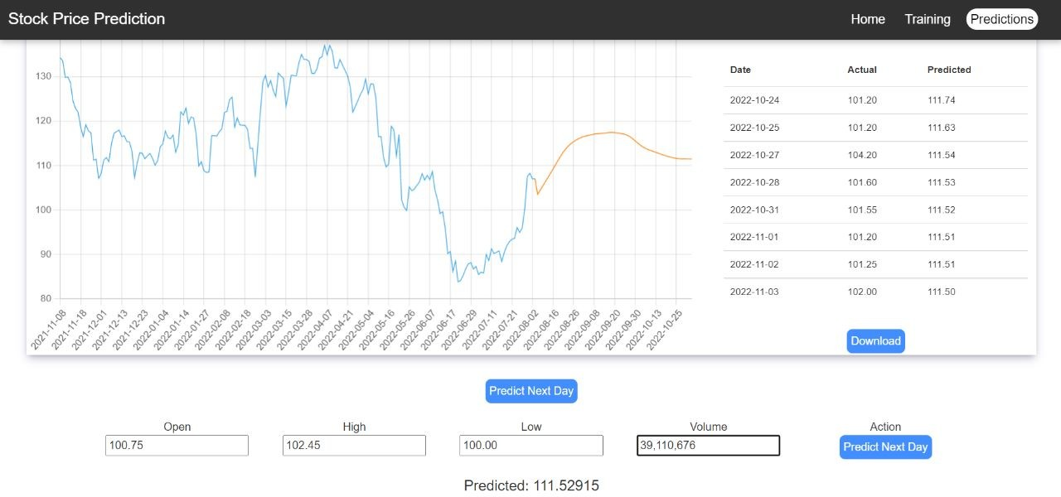

# Chapter 5

**Conclusion and Future Work**

## Conclusion

In this project, we are going to predict the closing price of stock which are of any given organization, we developed a web application for predicting close stock price using LSTM and LMS algorithms for prediction. We have applied datasets belonging to Gogle, Nifity50 and Reiliance Stocks and achieved above 93

## Future work

We want to extend this application for predicting.We want to add sentiment analysis for better analysis.

# References

1. Zexin Hu, Yiqi Zhao, and Matloob Khushi. A survey of forex and stock price prediction using deep learning. *Applied System Innovation*, 4(1):9, 2021.
2. Xuan Ji, Jiachen Wang, and Zhijun Yan. A stock price prediction method based on deep learning technology. *International Journal of Crowd Science*, 2021.
3. Kaustubh Khare, Omkar Darekar, Prafull Gupta, and VZ Attar. Short term stock price prediction using deep learning. In *2017 2nd IEEE international conference on recent trends in electronics, information & communication technology (RTEICT)*, pages 482–486. IEEE, 2017.
4. Mahla Nikou, Gholamreza Mansourfar, and Jamshid Bagherzadeh. Stock price pre- diction using deep learning algorithm and its comparison with machine learning al- gorithms. *Intelligent Systems in Accounting, Finance and Management*, 26(4):164– 174, 2019.
5. Hadi Rezaei, Hamidreza Faaljou, and Gholamreza Mansourfar. Stock price pre- diction using deep learning and frequency decomposition. *Expert Systems with Applications*, 169:114332, 2021.
6. Sreelekshmy Selvin, R Vinayakumar, EA Gopalakrishnan, Vijay Krishna Menon, and KP Soman. Stock price prediction using lstm, rnn and cnn-sliding window model. In *2017 international conference on advances in computing, communica- tions and informatics (icacci)*, pages 1643–1647. IEEE, 2017.